Low Level Design (LLD)

**FLIGHT FARE PREDICTION**

Document Version: 0.1

Document Version Control:

|  |  |  |  |
| --- | --- | --- | --- |
| Version | Date | Author | Description |
|  |  |  |  |
|  |  |  |  |
|  |  |  |  |

**Contents**

1. Introduction 3
   1. What is Low-Level design document ? 3
   2. Scope 3
2. Architecture 3
3. Architecture Description 4
   1. Data Gathering 4
   2. Data Description 4
   3. Tool Used 5
   4. Data Pre-processing 5
   5. Model Building 5
   6. Data from User 6
   7. Data Validation 6
   8. Rendering Result 6
   9. Deployment 6
4. Unit Test Cases 6

## Introduction

### What is Low-Level design document?

The main purpose of this LLD documentation is to feature the required details of the project and supply the outline of the machine learning model and also the written code. This additionally provides the careful description on however the complete project has been designed end-to-end.

# Scope

Low-level design (LLD) is a component-level design process that follows a step-bystep [refinement](https://en.wikipedia.org/wiki/Refinement_(computing)) process. This process can be used for designing data structures, required software architecture, source code and ultimately, performance algorithms. Overall, the data organization may be defined during requirement analysis and then refined during data design work

## Architecture

Import python libraries and read data

Data Processing

EDA

Handling categorical data

Saving Data in Pickle File

Hyper Parameter Tuning

Model Building

Feature Selection

Create a webpage Using Streamlit for Deployment

Deployment on AWS Cloud

Input Value and Predict Final Result

End

## Architecture Description

This project is to make associate interface for the user to grasp their approximate flight price ticket worth, additionally to the present, in would like of obtaining the important time project expertise we have a tendency to square measure mercantilism the gathered information into our own information then begin the project from the scratch.

### Data Gathering

The data for the current project is being gathered from Kaggle dataset, the link to the data is: <https://www.kaggle.com/nikhilmittal/flight-fare-prediction-mh>

### Data Description

There are about 10k+ records of flight information such as airlines, data of journey, source, destination, departure time, arrival time, duration, total stops, additional information, and price. A glance of the dataset is shown below.

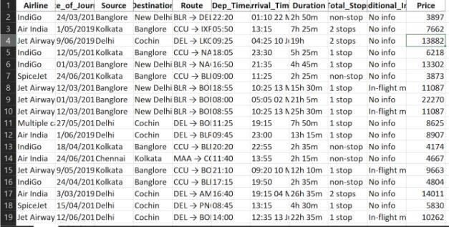

### Tool Used

* Python 3.9 is employed because the programming language and frame works like numpy, pandas, sklearn and alternative modules for building the model.
* PyCharm is employed as IDE.
* For visualizations seaborn and components of matplotlib are getting used
* For information assortment prophetess info is getting used version management.
* AWS is employed for deployment
* DVC is used for tracking data versions.
* MLflow is used to track for model experiments tracking.

### Data Pre-processing

Steps performed in pre-processing are:

* + First the info sorts square measure being checked and located solely the value column is of sort number.
  + Checked for null values as there square measure few null values, those rows square measure born.
  + Converted all the desired column into the date time format.
  + Performed one-hot cryptography for the desired columns.
  + Scaling is performed for needed information.
  + And, the info is prepared for passing to the machine learning formula

### Model Building

The pre-processed information is then envisioned and every one the specified insights are being drawn. though from the drawn insights, the info is at random unfold however still modelling is performed with completely different machine learning algorithms to form positive we tend to cowl all the chances. and eventually, for sure random forest regression performed well and any hyperparameter calibration is finished to extend the model’s accuracy.

### Data from User

The data from the user is retrieved from the created HTML web page.

### Data Validation

The data provided by the user is then being processed by app.py file and validated. The validated data is then sent for the prediction.

### Rendering Result

The data sent for the prediction is then rendered to the web page.

### Deployment

The tested model is then deployed to AWS. So, users can access the project from any internet devices.

* 1. **Unit Tests**

